



Solution Design Document

SmartForm

Version1.0

**February 27, 2019**

Document History

|  |  |  |  |  |
| --- | --- | --- | --- | --- |
| Version No | Created/Modified By | Reviewed By | Release Date | Modifications Done |
| 1.0 | Siva Audina | Mohan Patil | 27-Feb-2019 | First Draft |

Table of Contents

1 Introduction 4

1.1 Document Purpose 4

1.2 Distribution List 4

1.3 In Scope 5

1.4 Out of scope 6

1.5 Assumptions 6

2 Systems Overview 8

2.1 Applications and Systems 8

Type of access required – SSO, credentials etc. 8

2.2 Applications Interfacing 8

3 Analysis 9

3.1 High-level components 9

3.2 Narrative Use Case and Detailed Process 9

3.3 Requirements 10

4 Solution Overview 13

4.1. Solution Diagram 13

5 Transaction Classification 20

6 SmartForm Wireframes 22

7 Configurable Screen Wireframes 22

8 WorkList Data Structure 22

9 Automation Data Structure 22

10 Master Table Data Structure 22

11 Data Structure ER Diagram 23

12 Input Processing and Output 23

12.1 Input 23

12.2 Processing 23

12.3 Output 23

13 API 24

14 Assets 24

15 Modules Flow 24

SmartForm Workflow 24

a. Exceptions 25

16 Logs 25

17 Reusable Components: 25

18 Coding Standards 25

19 Frequency – Put in Scheduling section 25

20 SLA- Put in Scheduling section 26

21 Report Generation 26

Share SQL queries to get below reports 26

22 Reference Documents 26

# Introduction

This document will provide solution and technical design of Data Management - SmartForms.

## Document Purpose

The purpose of this document is to explain the technical design and overview of SmartForms implementation for the Data management.

Its main purpose is to –

* Provide the link between the functional specification and the detailed technical design documents
* Detailed functionality provided by each component or group of components and show how the various components interact in the design
* Provide a basis for SmartForms detailed design and development
* This document is not intended to address installation and configuration details of the actual implementation. Installation and configuration details are provided in technology guides produced during project

As is true with any high-level design, this document will be updated and refined based on changing requirements.

## Distribution List

|  |  |  |
| --- | --- | --- |
| Name | Role | Notes |
| Orla Weare - Business  Ashok Verma – Technology | Project Owner | Overall project owner and Level 1,2 escalation |
| Abhinav Sharma | Business Analyst | Point of contact for process related queries |
| Nitin Agarwal- RPA  Ewa Ziemkowska- Smart Form | Business PM | Point of contact for process related queries |
| Gary Tessler and Malissa Ford | Tech Solutions PM | Point of contact for process related delivery |
| KJ Davis | Tech Solutions | Point of contact for process related delivery |
| Mohan Patil | PM | Point of contact for process related delivery |
| Siva Audina | Tech Architect | Point of contact for process related delivery |

## In Scope

Build a web-application (Smart Form) to:

* Serve as a single-entry point for data management requests globally.
* Redirect the appropriate transactions to PeopleSoft self-service.
* Intake all transaction for Data management including includes Personal and Job changes
* Self-Service: Below is the list of transactions:

Address

Contact Details

Disability

Emergency contact

Ethnicity

Gender

Preferred Name

Veteran Info

Business title

Company

Department

FCLM Area and FCLM job

Full time - Part Time

Pay group

Product Line

Shift Pattern and ADP shift

Supervisor change

* Non-Self-service: Below is the list of non-self-service transaction

Bank Account details

Bank Account Number

CRI National ID

Date of Birth

Educational qualification

Legal Name

Marital Status

National ID Upload

SSN/SIN/National ID

Visual Survey Conducted

Work Permit Details

Agency

Amazon Discount Code

Business Unit

EA (Executive Assistance)

Eligibility

Employment Date

Job Code

Location

M&A Hire/Re-Hire

Office Location Change

Part time Work Arrangement- FWA

Promotions

Public Transportation Reimbursement

Seasonal-Individual

Shift- Individual (CR)

Standard Hours

Status Change

Suspension

Telecommuting-Individual

* Validate bulk requests for accuracy of each row for transaction that are in scope for bulk uploads
* Escape valve is created to allow the requester to generate a ticket out from Smart form. Enable escape valve to capture the reason if the user is unable to use self-service or generate a ticket.
* Reduce the volume of manual ticket processing such as Fake self Service (department for initial release)
* For Non self-service transaction provide a web form which will validate and capture request from user before creating the ticket (via API or Quicklink) or making output ready for RPA
  1. Out of scope
* Requests made with unsupported file formats (not a .csv, .xlsx, .xls,xlsm file format)
* Approval workflow (Approvals attached)
* Worklist workflow
* Master Data Import/Processing (DM)
* **Repo**rting Functions (Queries only)
* Infrastructure in the Amazon environments
* Deployment into Production
  1. Assumptions
* General Assumptions
  + All environments will be configured and setup by Amazon
  + All developmental software’s will be provided by Amazon
  + Development infrastructure will be provided and maintained by Amazon
  + Training on Amazon tools and software’s will be provided to LTI
  + Alpha and Beta environment access will be provided to LTI
  + Third party application access will be provided to LTI by Amazon
  + Post production all environments and Applications/Databases will be maintained by Amazon
* Responsive UI Development is based on the following assumptions:
  + HTML 5.0 and CSS 3.0 development for 10 Templates (No CSS processors)
  + Browser compatibility details (latest versions of Chrome, Firefox, Safari and IE 11+) will be shared to LTI
* Integration is based on the following assumptions:
  + SSO details will be shared by Amazon
  + After authentication Token will be shared with SMF application. SMF will validate the Token and provide access to the user.
  + SMF expects employee ID through the header which will be used to identify role and
  + Amazon will share the flat file dump with LTI
  + PeopleSoft access will be provided by Amazon
  + WF API (TT) details will be shared by Amazon
  + For notification, SMTP details will be shared by Amazon

1. Systems Overview­­

*This Section depicts the Application/System being used in current process and what Application/System will be used after automation implementation. Sections will be detailed as information is made available during build and development.*

* 1. Applications and Systems

|  |  |
| --- | --- |
| Applications | URL *(if any)* |
| SmartForms | Alpha:  Beta:  Gamma:  Delta: |
| PeopleSoft | Alpha:  Beta:  Gamma:  Delta: |
| Remedy | Alpha:  Beta:  Gamma:  Delta: |
| Federate | Alpha:  Beta:  Gamma:  Delta: |
| Databases/Schema | Alpha:  Beta:  Gamma:  Delta: |
| SMTP | Alpha:  Beta:  Gamma:  Delta: |

Type of access required – SSO, credentials etc.

* 1. Applications Interfacing

|  |  |
| --- | --- |
| Applications/Systems | Interfacing mechanism |
| SmartForms | Through SmartForms UI |
| PeopleSoft |
| Remedy TT |
| SMTP |

# Analysis

## High-level components



* 1. Narrative Use Case and Detailed Process

|  |  |
| --- | --- |
| Use Case Name | Data Management - SmartForms |
| Goal in Context | Smart Form application will alleviate the manual work associated with follow ups, increase usage of available self-service and help structure and validate input, to increase RPA success rate. Smart Forms will also provide a better user experience to employees and HR generalists, guiding users to the right channel to resolve their request quickly and first time right. |
| Pre-conditions | The appropriate approvals and supporting documentation have been obtained. |
| Success End Condition | People soft will be updated with user entered data either through self-service, automation, or manually by the Data Management team. |
| Primary Actor | ESS, MSS, and GSS classified users |

* 1. Requirements

GUI / SCREEN DESIGN FOR WEB APPLICATIONS: *Details to be added as work progresses through development and build.*

| GUI Aspects | Considerations / Alternatives | Details and (optional) Rationale |
| --- | --- | --- |
| Usage of Frames | Yes / No |  |
| Usage of Style sheets (CSS) | Yes |  |
| Sitemap | No |  |
| Menu organization and Navigation | Top Menu |  |
| Technologies | HTML5, CSS3, Angular6, Bootstrap4 and NodeJs |  |
| Colour Scheme | Single scheme for all pages |  |
| Images and their size and quality | PNG / JPEG  Size |  |
| Max page size | Kbs |  |
| Usage of Page ID apart from Page title | Not required |  |
| Screen Resolution | 1366x768, 800 x 600, 1024 x 768, 1024×576, 1152×648, 1280×720, 1366×768, 1600×900, 1920×1080 |  |
| Browser support | IE 11+, Chrome, Firefox, Safari |  |
| Validation | Common validation / Individual validation |  |
| Error message display locations | TBD |  |
| Search Facility and Technology | NA |  |
| Support for search engines | NA |  |

**Services DESIGN FOR WEB APPLICATIONS**: *Details to be added as work progresses through development and build.*

| GUI Aspects | Considerations / Alternatives | Details and (optional) Rationale |
| --- | --- | --- |
| Technologies | Java 1.8, Spring 5+  Hibernate 4.0  MySQL 7.0 |  |
| Validation | Common validation / Business Rules validation |  |
| Error message | TBD |  |
| Search Facility and Technology | Elastic Search |  |
|  |  |  |

**INTEGRATION DESIGN FOR WEB APPLICATIONS**: *Details to be added as work progresses through development and build.*

|  |  |  |
| --- | --- | --- |
| Integration Aspect | Consideration/ Alternatives | Details and (optional) Rationale |
| Restful web service | Yes/No |  |
| Technologies | JDK 1.8, Spring 5, Maven, Eclipse, SVN/GitHub, Tomcat |  |
| Validations | Common validation / Individual validation |  |
| Error message | TBD |  |

**CODING UI:** *Details to be added as work progresses through development and build.*

| Code Element | Considerations / Alternatives | Details and (optional) Rationale |
| --- | --- | --- |
| Documentation | Angular.io |  |
| HTTP Method | GET, POST |  |
| Common Header & Footer and Includes | Yes |  |
| Session Cleaning |  |  |
| Database Connection |  |  |
| Screen Validations | Date, Trim, Max size, Browser Compatibility, Format, Field type |  |
| Security | Restricting intermediate URL access for valid & invalid users |  |
| Folder/ Package Structure | Yes |  |

**CODING Services:** *Details to be added as work progresses through development and build.*

| Code Element | Considerations / Alternatives | Details and (optional) Rationale |
| --- | --- | --- |
| Documentation | Java Docs |  |
| HTTP Method | GET, POST |  |
| Session Cleaning |  |  |
| Database Connection |  |  |
| Security | Restricting intermediate URL access for valid & invalid users |  |
| Folder/ Package Structure | Yes |  |
|  |  |  |

*Final Solution design will be ready once the clarification is received.

# Solution Overview

## 4.1. Solution Diagram

1. Smart Form Solution Flow

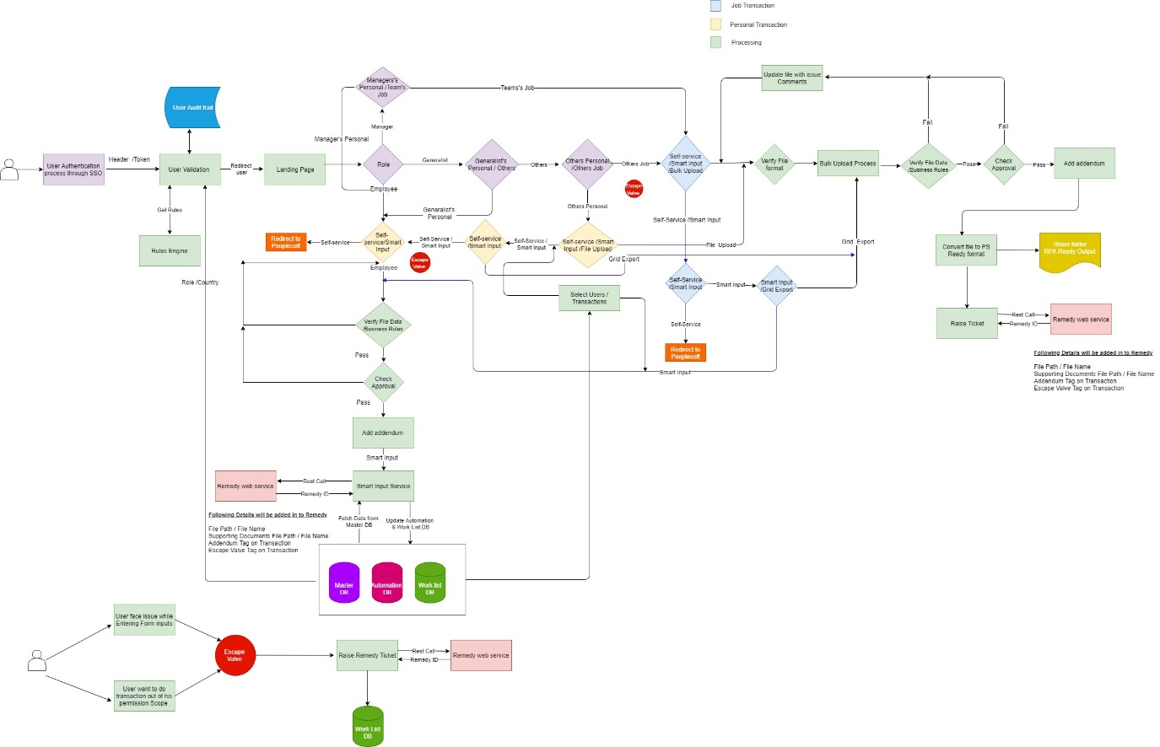

Figure 1 Smart Form Solution Flow Diagram

* From inside the Amazon network the user accesses the Smartform URL and is authenticated by Single Sign On.
* User will be routed to the correct landing page based on his/her role. Only the appropriate transactions and fields will be visible to the user determined by business rules.
* Users can perform both Personal and Job Data transactions based on their persona and location information.
* Transactions are further divided into Self Service, Non-Self-Service and Bulk Upload
* For self-service transactions, user will get redirected people portal when appropriate. If smart input is permissible either a Remedy ticket will be created for manual handling or a file will be created for automated processing.
* Before creating ticket there is a check for business rule validation
* After that there will be check for approval and then checking for addendum
* In both cases the Worklist is updated to reflect the activity.
* For non-self-service transactions, user will provide input (manually keyed or File Upload) into Smartform. A ticket will get created in ‘Remedy’ and the ticket id will get updated in ‘Worklist DB’. A new entry will get created in the transaction table with the worklist Id.
* For a bulk upload, user can submit CSV, Excel, XLS file formats.
* Check whether file is validated according to business rules then check for approval and after that check for addendum
* Employee (ESS) can only change their own personal details. Managers (MSS) can change their personal details and others job details, but a manager is not allowed to change anybody else’s personal details. Generalist (GSS) can make personal changes as well as job details changes for others and themselves.

1. Bulk Upload Process:

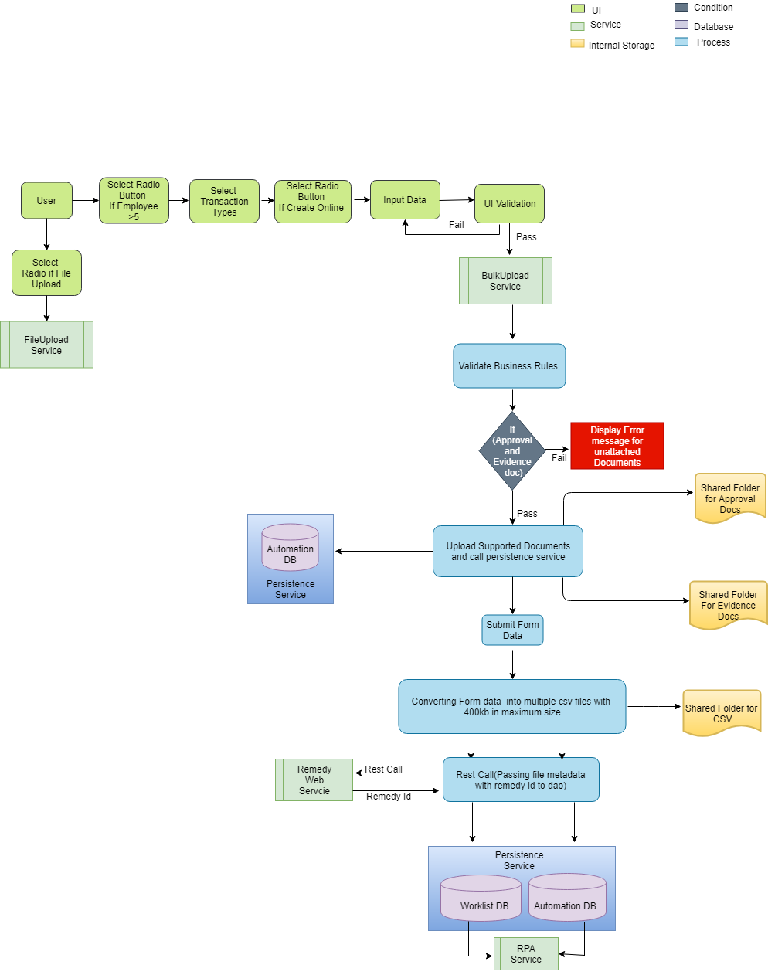

* Bulk upload is the functionality to perform multiple transactions for multiple employees.
* Requestee should select the radio button if employee greater than 5 and transaction type to perform bulk upload.
* If it is file upload then call file upload service.
* If it is create online then UI validation to be performed after input the data.
* A bulk upload service to be invoked to validate business rules.
* If approval and evidence document is attached then documents should be stored in shared folder and call persistence service to update automation database.
* If approval and evidence document is not attached then display error message in the UI.
* Once all validation performed, convert form data in to multiple csv files with 400kb as maximum size and store in to share folder.
* Call remedy service to get remedy id.
* Pass file metadata along with remedy id and call persistence service to update worklist and automation database.

1. File Upload

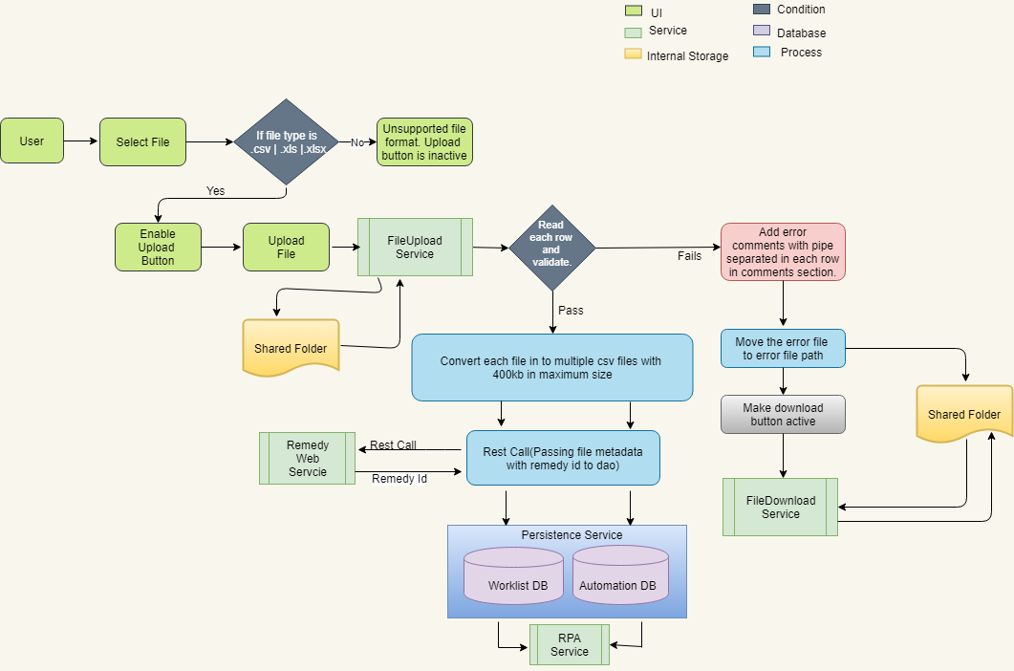

* File upload is the functionality to perform single or multiple transactions for multiple employees in a file.
* Requestee can upload either .csv, .xls or .xlsx files and the file can contain records for single transaction or multiple transactions.
* User can upload file of any size but internally Smartform will convert larger files into multiple 400 kb files.
* Smartform will validate the data in the file and add a comment for all invalid records. The file and comments are provided to the user, the user can then make correction into data and re-upload file for validation. The cycle continues until a clean file is uploaded.
* For each file upload, an entry is made in the Worklist and Automation database, a file is placed into the appropriate shared drive folder and a ticket is opened in Remedy.

1. Remedy service - *Details to be added as work progresses through development and build. Section will detail interaction between solution components, connectivity and contract details for the WFA API.*

1. Single Sign On (SSO) *- Details to be added as work progresses through development and build. Section will detail interaction between solution components, connectivity and contract details for the API.*
2. User Validation

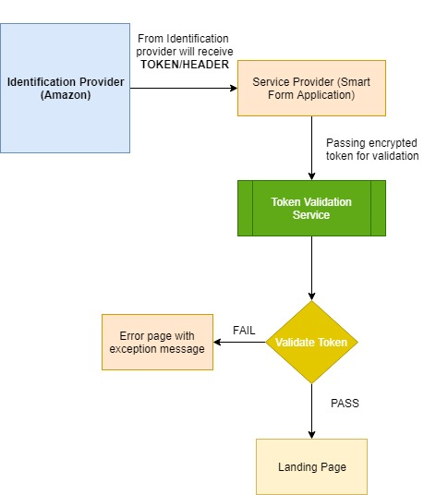

1. Notification service- *Details to be added as work progresses through development and build.*

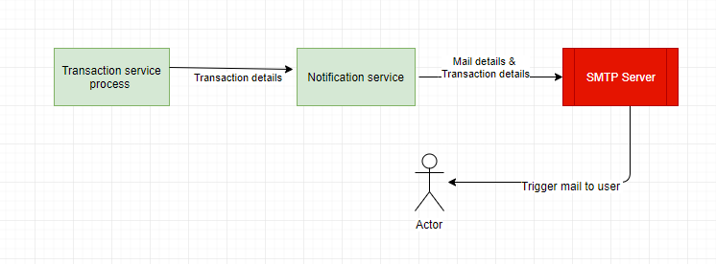

* Transaction service is responsible for sending notifications to requester or to the appropriate teams.
* Transaction service will provide transaction details to notification service. Notification will be sent including appropriate recipients and transaction details through SMTP server.

1. Configuration service - *Details to be added as work progresses through development and build.* 
   1. Smartform will provide a UI to:
      1. Define transactions routed to PeoplePortal
      2. Turn Notifications on/off based on transaction
      3. Ticket creation enable/disabled for a given transaction.
2. Self-Services

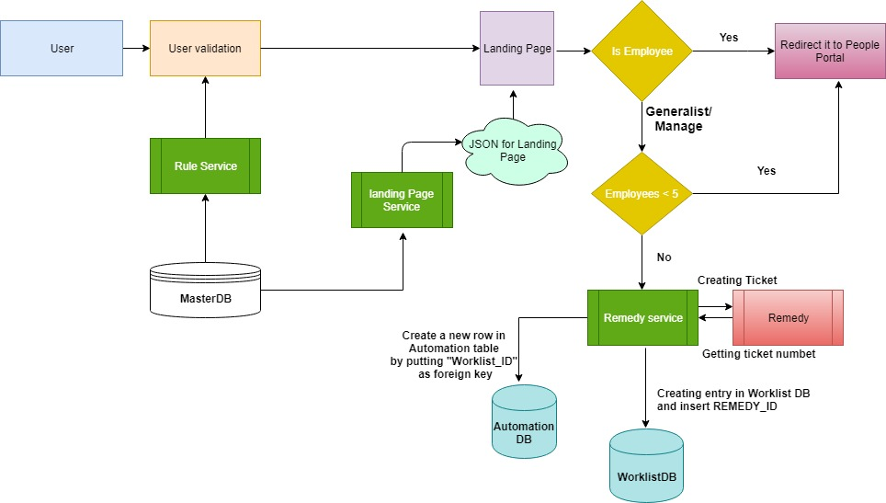

1. Smart Form Input Service

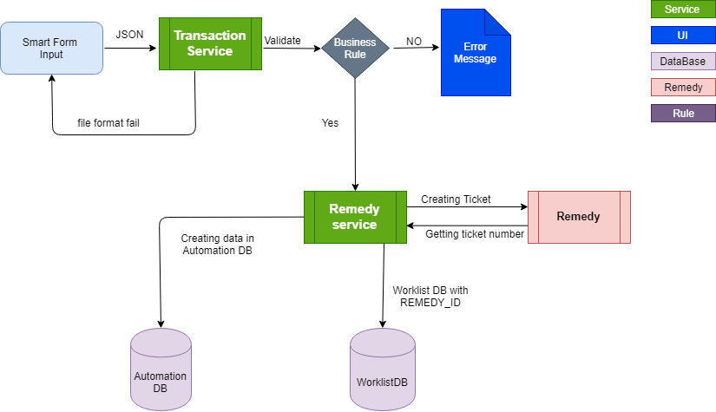

1. Work List Service:

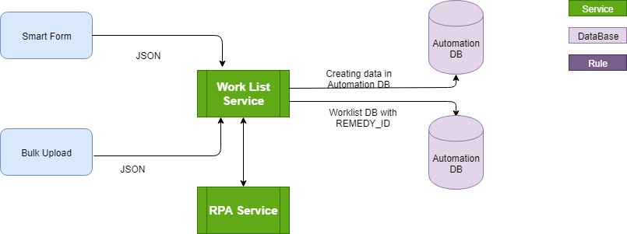

# Transaction Classification

|  |
| --- |
| **Transaction type**: Self Service (ESS, MSS) |
| * After successful login, user will be redirected to landing page. * Landing page will be rendered with user personal transaction and previous requests available for review. * User will select the personal transaction and will be routed to PeopleSoft portal by clicking the link provided. |
| **Technical view**: *Details to be added as work progresses through development and build*   1. Authentication & Authorization 2. User details and rules required to render the correct landing page 3. Data required from the Master Database 4. Services utilized to support the functionality |

|  |
| --- |
| **Transaction type**: Smart Input (ESS, MSS,GSS) |
| * After successful login, user will be redirected to landing page. * Landing page will be rendered with Personal & Job Data transactions as well as previous requests available for review. * User will select the desired transaction type and provide the Smart Input to complete the request. |
| **Technical view**: *Details to be added as work progresses through development and build*   1. Authentication & Authorization 2. User details and rules required to render the correct landing page 3. Data required from the Master Database 4. Services utilized to support the functionality |

|  |
| --- |
| **Transaction type**: Bulk – Smart Input |
| * After successful login, user will be redirected to landing page. * Landing page will be rendered with Personal & Job Data transactions as well as previous requests available for review. * User (Manager/Generalist) will select the desired transaction type and provide the Smart Input for a minimum of 5 employees. |
| **Technical view**: *Details to be added as work progresses through development and build*   1. Authentication & Authorization 2. User details and rules required to render the correct landing page 3. Data required from the Master Database 4. Services utilized to support the functionality |

|  |
| --- |
| **Transaction type**: Bulk – File Export |
| * After successful login, user will be redirected to landing page. * Landing page will be rendered with Personal & Job Data transactions as well as previous requests available for review. * User (Manager/Generalist) will browse to the Bulk file and upload for validation. |
| **Technical view**: *Details to be added as work progresses through development and build*   1. Authentication & Authorization 2. User details and rules required to render the correct landing page 3. Data required from the Master Database 4. Services utilized to support the functionality |

# 

# SmartForm Wireframes

*The wireframe representation of SmartForm is focused on functionality and not visual appeal. The design is in progress and final wireframes will be based on the culmination of feedback and collaboration. Smartform Wireframes are for transaction processing and validation.*



# Configurable Screen Wireframes

*The wireframe representation of Configurable Screens is focused on functionality and not visual appeal. The design is in progress and final wireframes will be based on the culmination of feedback and collaboration. Configurable Screen wireframes will define transactions routed to PeoplePortal, turn notifications on/off, and enable/disabled ticket creation for a given transaction.*



# WorkList Data Structure

*Worklist is the future hub of Data Management. Worklist will track any transaction for multiple systems in a central repository. Details to be added as work progresses through development and build*



# Automation Data Structure

*The Automation Data structure contains the transactions, business rules, and exception handling for the Rules Engine and transaction processing. Details to be added as work progresses through development and build*



# Master Table Data Structure

*The master table data structure is the export of employee and supporting information from People Soft.* *Details to be added as work progresses through development and build.*



# Data Structure ER Diagram

*The Entity Relationship Diagram is the logical relationship between the objects in the associated schemas.* *Details to be added as work progresses through development and build.*



# Input Processing and Output

# Input

* User either manually keys the data or uploads a file through Smart Form
* Pseudocode UI contains basic error handling for nulls, data types, prohibited values, etc. and the messaging to users based on the validation applied. It is not the actual code to be used but a logical flow representation of the rules.
* *Details to be added as work progresses through development and build.*



# Processing

* As per user request, redirect Self Service requestor user to PeoplePortal
* Based on transaction, validate data entered by user and save data in Automated Database, raise Remedy Ticket, create entry in WorkList Database
* Based on transaction, validate data entered by user, create (.csv) file(s) (max of 400 kb per file) and save those file(s) on Shared folder, add file path and name(s) in Automated Database, raise Remedy Ticket, create entry in WorkList Database
* Based on transaction, validate file uploaded by user, create (.csv) file(s) (max of 400 kb per file) and save those file(s) on Shared folder, add file path and name(s) in Automated Database, raise Remedy Ticket, create entry in WorkList Database
* Pseudocode UI contains the logic the functions of SmartForm. It is not the actual code to be used but a logical flow representation of the rules.
* *Details to be added as work progresses through development and build.*



# Output

* The expected result of processing the inputs. The output can be a manual ticket if designated by business rules or from error handling. In some instances, the user is directed to the PeoplePortal as the desired end state. There is also manual data entry and Bulk Files processed into PeopleSoft as an output. *Details to be added as work progresses through development and build.*

# API

This section will list the services utilized by the solution. *Details to be added as work progresses through development and build.*

* Remedy (WFA API)
* SMTP

# Assets

* The Smart Form solution is integrated with several components: *Details to be added as work progresses through development and build.*

PeopleSoft

Federate

Databases/Schema

SMTP

PeopleSoft

Remedy (WFA API)

# Modules Flow

## SmartForm Workflow

* Employee land on Smart Form page
* Page is pre-populated with requestor indicative detail and probing navigation
* Is this about you or someone else
* Individual Vs Bulk Request
* Is this about transaction for which smart input can taken
* Employee write data in form which will create a worklist or Excel o/p
* RPA ready o/p
* Validated o/p for ticketing
* Validation of transaction. Can this be done without Remedy Ticketing
* Pure Redirect to Self- Service
* Fake self Service
* RPA ready o/p
* Validation of request and attachment.
* Convert the bulk request into a worklist or Excel
* RPA ready o/p
* Escape Valve

## Exceptions

|  |  |
| --- | --- |
| Exception | Description |
| Application Exception | Peoplesoft / Salesforce applications are down |
| Business Exception | Yet to receive from the Client |

# Logs

* Log information can be stored in Server log folder.
* Logs will be captured for each transaction from smart form

Transaction Log would have the following details

* Transaction Name
* Transaction time
* Transaction Exception Details (In case of any errors)

# Reusable Components:

* Wireframes
* Visual Designs
* HTML and CSS
* UI Common Components
* Common Services
  + Remedy Service
  + RPA Service
  + Notification Service
  + Work List Service
  + Rules Service
  + Admin Service

# Coding Standards



# Frequency – Put in Scheduling section

* NA

# SLA- Put in Scheduling section

SLA is to verify all the applications received on the same day (TBC)

# Report Generation

# Share SQL queries to get below reports

1. Transaction Report: Capture detail of all transaction happens inside SMF



1. Ticketing detail report: It can be task report to capture all ticket or case id that come out of interaction with SMF.



# Reference Documents

|  |  |
| --- | --- |
| File Description | File Reference |
| Functional Requirement Document |  |
| Discovery Package |  |
| Transaction Document |  |